INTRODUCTION

Ronald Lauder

In this project we would like to present the life and work of the president of the World Jewish Congress, Ronald Lauder.
He is a very influential businessman, who is an heir to his mother’s company “Estee Lauder”. Right now, the one who is responsible with the management of the company is Leonard Lauder, his brother. An important influence for Lauder was his mother, Estee Lauder, who founded and raised her company with her husband, combating all the obstacles that they encountered.
Ronald has founded several Jewish schools in many countries from the Eastern Europe, most of them being former communist states. He started the Ronald S Lauder Foundation which helped to establish our school, the Lauder-Reut Educational Complex, in Bucharest, now known as the Laude-Reut Educational Complex.
During his stay in Romania, he helped the development of the state, by founding several private companies that were soon to flourish. The most popular one that he established is the television post, PRO TV, who still is the most watched program in the country. Beside this, he is also the founder of CME (Central European Media Enterprise), a company which establishes television programs in central Europe.
He was involved in the diplomatic field, serving as the ambassador of the United States in Austria from 1986 until 1987. Furthermore, he is the President of the World Jewish Congress since 2007, having the lead for nearly 13 years.
As a Jew who had seen the horrors of the Holocaust and whose relatives were horrendously murdered in Auschwitz, he has established peace with the nations involved and helped the Jews that survived the terrible events.

Chapter I

Diplomatic work

Ronald S. Lauder is a very active figure in the diplomatic word, occupying many positions during his life.
His first involvement in the politics was in 1983, when he became the United States Deputy Assistant Secretary of Defense for European and NATO Affairs. He served there for 3 years, until 1986, when he was appointed by President Reagan as US Ambassador to Austria. There, he built strong diplomatic bonds between the two countries, emphasizing his appreciation and commitment to his Jewish heritage.
In 1977, he was elected as the President of the Jewish National Fund and after a successful 10-year tenure, became Chairman of the Board. He also served as Chairman of the Conference of Presidents of Major American Jewish Organizations.
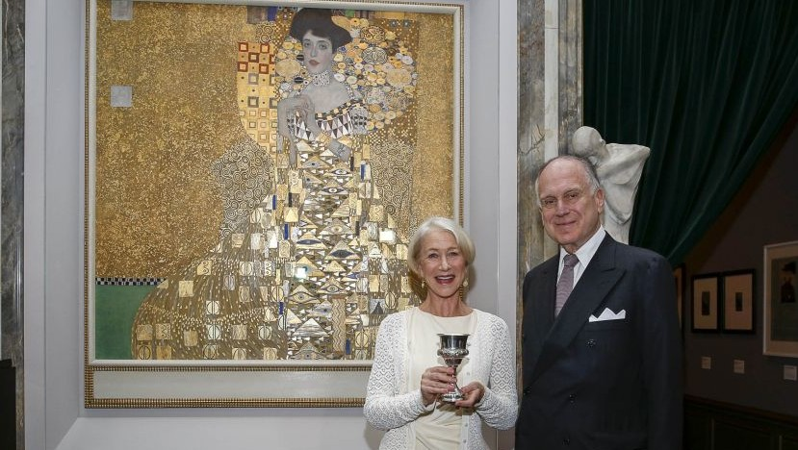
Lauder’s passion for art and his commitment for justice led him to create and head the Committee for Art Recovery that has helped establish international laws to recover art stolen by the Nazis during World War II. In 2006, he bought “Woman of Gold” otherwise known as Portrait of Adele Bloch-Bauer I by Gustav Klimt for $135 million, the highest price ever paid for a painting at that time.
In June of 2007, he was elected as the president of the World Jewish Congress. As the head of the Jewish umbrella organization, he has met with many important and influential figures, such as the German Chancellor Angela Merkel and Pope Benedict XVI.
In 2008, he was appointed by the US President George W. Bush, to serve on the honorary delegation to accompany him to Jerusalem for the celebration of the 60th anniversary of the State of Israel.
Lauder is still the president of the World Jewish Congress, having the lead for almost 13 years.

In my opinion, Lauder is a very active and devoted diplomatic figure, who has done and is still doing hard work towards Jews rights. His involvement in the diplomatic field has flourished along the years, becoming more and more influential. From defending Jews rights to buying and restituting art which was stolen by the Nazis during World War 2, he has been trying through his work to embrace his roots and to cherish them.
I believe that he deserves his place as the President of the World Jewish Congress, being involved in many projects and organizations that preserve art, such as the International Society for Yad Vashem or the International Board of Governors of the Tel Aviv Museum.

In this chapter I used 4 sources:
1.Wikipedia https://en.wikipedia.org/wiki/Ronald_Lauder
2.World Jewish Congress https://www.worldjewishcongress.org/en/about/president
3. The Times of Israel https://www.timesofisrael.com/us-house-passes-bill-to-ease-return-of-nazi-looted-art/
3. Word from Jerusalem https://wordfromjerusalem.com/ronald-lauder-a-unique-global-jewish-leader/

Chapter 2

Josephine (Estee) Lauder

Estee Lauder had always had a thing for skincare and finding new
ways to make her complexion seem more radiant. She had a familial
influence, as her uncle, John Schotz, was a chemist and had started to
teach her how to make her own creams from a young age.
She started her life as a business woman from her teenage years,
when she used to sell her products to a local salon, beach clubs and a
resort, after a lot of people complimented her skin and asked her about the
products that she used. The strategy that she used was to give free
samples, and after that, if the customer enjoyed the product, Lauder would
sell it as a “Jar of hope”.
Later on she married Joseph Lauter, later called Lauder, who owned
a garment company at that time. After the birth of their second child,
Ronald, the cosmetics business took a turn for the better, getting an $800
from Saks Fifth Avenue. The products sold out in only 2 days, as a result of
the newly implemented marketing method: giving free products for every
purchase, that was implemented by her.
The brand started to expand outside of the US, as new brands like
Clinique and Aramis, specialized for men launched.
Estee was one of the first women to achieve so much, speaking not
only business related, but also talking about the people that she had met
during her life. She spent her free time enjoying the company of social
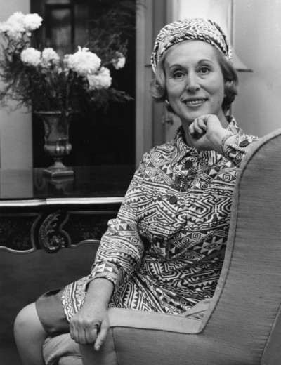
elites, like the Duchess of Windsor, Willis Simpson or The Princess Grace
of Monaco.
Josephine had always had the entrepreneurship sense in her, as she
spent her childhood working in a local hardware store. She didn’t always
live the luxurious lavish life. Coming from a family of eight, it was sometimes hard for the parents to make ends meet.
When she was little, Lauder had always wanted to become an
actress. She had always loved the idea of having her name written in bold
lighted letters and wanted to be surrounded by handsome men.
I think that Josephine Lauder is an influence for all of us. She had always had a dream and a wish to become seen by the world. As she said in an
interview, she didn’t only dream to achieve her goal, Estee put up with a lot
of problems, overcame obstacles, and always worked hard, no matter the
events that happened in her personal life. I found it inspiring that she knew
the borders in her life. She never overlapped aspects of her life, and for me
that is the key to being successful, knowing your limits.
Looking at her biography and seeing what she was on about since she was
little, you can see that Josephine knew how to learn from the experiences
that life showed her, and that helped her when she was demanded certain
skills.
In my opinion, Estee Lauder is a very important part of Ronald’s life, as she is the woman that formed him and guided him in the world of business.

In this chapter I used 4 sources:
- Wikipedia https://en.wikipedia.org/wiki/Est%C3%A9e_Lauder_(businesswoman)
- The Famous People https://www.thefamouspeople.com/profiles/estee-lauder-173.php
- Entrepreneur https://www.entrepreneur.com/article/197658
- Britannica https://www.britannica.com/biography/Estee-Lauder

Chapter 3
Leonard Lauder

Well know for his family’s business, Leonard had always prepared to take the reins to his mother company. Following Wharton School of the University of Pennsylvania, a well known Ivy League institute, he was later on a lieutenant in the U.S. navy.
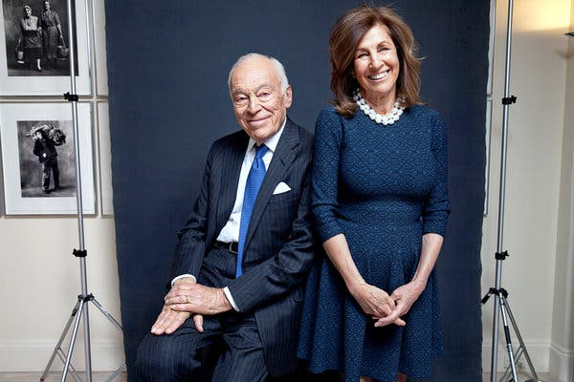
As one of his interests is art, he spent a lot of his time collecting rare pieces, mostly painted by cubist artists, like Picasso, from whom he had collected over 30 pieces of art. In 2013, he promised to donate all his artwork collection to the Metropolitan Museum of Arts in New York City. Along with his brother, Ronald, he had started the fight to end Alzheimer’s and related dementias, by founding the Alzheimer’s Drug Discovery Foundation. The organisation emphasises the acceleration of the development of the curing drugs. Research centres and labs across the U.S. can receive founding if they want to investigate the illness. The organisation is known worldwide, and some of the wealthiest businessmen in the world, like Bill Gates are donating to this cause.
He established the Leonard Arnold Lauder Research Centre for Modern Art, at the Metropolitan Museum of Art in New York City, that encourages people of all ages to discover the story hidden by paintings. It provides people with information about Cubist art as well as digital archives. There are special programmes that people can enrol in as to follow art courses. After obtaining this diploma, they can be offered jobs at the gallery.
2020 is a meaningful year in Leonard’s life, as his memoir is promised to be launched. He promises to include leadership advice, as well as insights to his life. One of the most important points that will be covered in the book will be the story of his success and how his ideas managed to get him where he is right now.
He now owns a portfolio of high top cosmetic brands, like MAC cosmetics, Bobbi Brown or Smashbox, covering all the levels of the beauty market, a performance that has been achieved by no one, but him.
I think that Leonard is offer the youngsters knowledge to all the domains that he loves. From his love of art to his wish of combating Alzheimer, the society only benefits from his contributions. Founding a clinical research organisation as well as an arts centre while managing a cosmetic empire and combating personal issues seems impossible, but for him, he makes it seem as if it were easy. Like all the other members of his family, he shows off his professionalism by not letting parts of his life interfering with one another, maintaining a balance between them.

In this chapter I used 4 sources:
- Wikipedia https://en.wikipedia.org/wiki/Leonard_Lauder
- The New York Times https://www.nytimes.com/topic/person/leonard-a-lauder
- Alz Discovery https://www.alzdiscovery.org/about-addf/our-founders
- Cosmetics business
https://www.cosmeticsbusiness.com/news/article_page/Leonard_Lauder_to_publish_personal_memoir_in_2020/157786

  - Chapter 4
  - The Ronald S Lauder Foundation

The Ronald S. Lauder Foundation philanthropy underwrites the future of Jewish life in Europe through supporting excellent Jewish schools.
An excellent school, according to Ronald Lauder, the founder, is “one that prepares young Jews for personal and professional success, and that inspires active participation in Jewish life”.
Recognizing the urgency of his mission, Lauder immediately established his foundation with Jewish education at its core when he returned to New York in 1987. Since then, the Ronald S Lauder Foundation has been rebuilding Jewish life in the eastern Europe, where the atrocity of the Holocaust was followed by the oppression of the Communist rule.
Today, The Ronald S. Lauder Foundation proudly operates and supports over fifty programs spread throughout a network of 13 countries: Austria, Belarus, Bulgaria, Croatia, Czech Republic, Greece, Germany, Hungary, Poland, Romania, Russia, Slovakia and the Ukraine.
To build better understanding between individuals living in different cultures, Lauder has created an International Student Exchange Program linking New York City high school students with their counterparts in Vienna, Budapest, Warsaw, Prague, St. Petersburg, Berlin and Sofia. Now in its 12th year of operation, the program is an integral part of The Ronald S. Lauder Foundation.

In my opinion, Ronald’s foundation is an act of kindness and appreciation for the Jewish culture. He has impacted the lives of the Jews that live in Eastern Europe, who were deprived of their culture and traditions. By founding all these schools, he made it clear that he is devoted to his heritage and to his people. Also, the exchange programs that he initiated between American and Eastern European schools gave children a chance to see and experience life in a different country, with different rules, foods, ways of teaching and entertainment. Ronald Lauder has given an enormous opportunity to thousands of students, opening a door again and making them feel confident and proud about their roots, giving them all the necessary tools to learn with devotion and pleasure all the subjects thought in school.
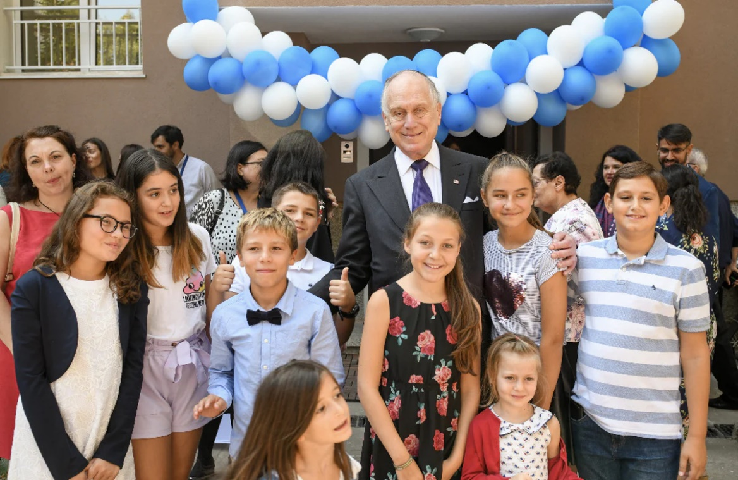
I believe that, without his work and implication, and without the education that he gave a lot of students through his schools, a lot of people wouldn’t have made so far in life. Many students who graduate from the schools in the foundation are accepted to top universities, such as Cambridge or Yale.

In this chapter I used 4 sources:
- Wikipedia https://en.wikipedia.org/wiki/Ronald_Lauder
- The Ronald S Laude Foundation https://lauderfoundation.com/
- Jewish Telegraphic Agency https://www.jta.org/sponsor/ronald-s-lauder-foundation
- The Times of Israel https://www.cosmeticsbusiness.com/news/article_page/Leonard_Lauder_to_publish_personal_memoir_in_2020/157786

Chapter 5

The Laude-Reut Educational Complex

The Laude-Reut Educational Complex, formally known as the Lauder Reut Educational Complex is a top highschool in Bucharest, Romania which was founded in 1997 by Ronald Lauder and Tova Ben Nun-Cherbis. Their mission was to revive and preserve the Jewish culture and Hebrew language in the European Diaspora, devastated by Holocaust and the Communist regime.
On 16th of May 2016, fulfilling all the academic and functional criteria set by the Ronald S Lauder Foundation, Lauder gave the high school its independence, Tova becoming the president of the Laude-Reut Educational Complex.
As Tova often told us, Lauder gave her the advice to start small, with just a kindergarten, and go bigger step by step. Today, 23 years later, the Laude-Reut Educational Complex has beside kindergarten, a primary and a secondary school, as well as a high school.
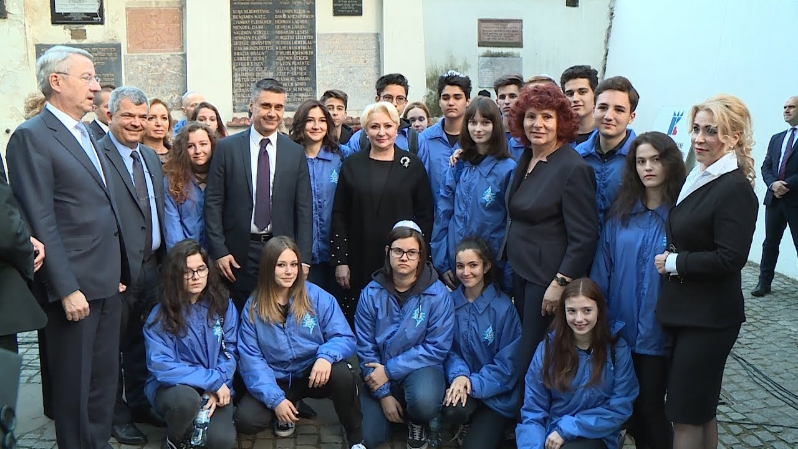
In the Laude-Reut Educational Complex the Jewish culture and traditions are cherished by sustaining many events and activities. The students of our school attend events about rememorating the Holocaust, such as March of The Living. Furthermore, there are various events that happen inside the school that teach the students about Jewish holidays, Jewish history and its diplomats.
I am proud to be in the Laude-Reut Educational Complex because it has given me the opportunity to develop my knowledge about the Jewish culture. It has given me a different point of view from which I can look at life. Understanding the atrocity of the Holocaust made me realize how cruel some people can be and it also made me grateful for what I have. Moreover, I am able to share my knowledge with other people and I am more aware of the xenophobia that exists in the world, and I am trying to combat it by showing others the beauty of the Jews and their culture and background. I believe that learning in a Jewish school has given me more opportunities that any other school I could have gone to in Bucharest, teaching me, besides mathematics, english and physics, a very important life lesson.

In this chapter I used 4 sources:
- Lauder Reut https://www.lauder-reut.eu/
- Laude Reut https://www.laude-reut.ro/
- Ziare http://www.ziare.com/scoala/scoli/anul-scolar-2019-2020-noutati-la-complexul-educational-laude-reut-1576722
- Ronald S Lauder Foundation https://lauderfoundation.com/

Chapter 6

75 Years since the liberation of Auschwitz and his influence on this matter

Lauder’s family has been part of the massacre of the Holocaust. They had been part of the last wave of people that reached Auschwitz, Birkenau, the worst extermination camp established by the Nazi. Most of them were taken by trains from Transylvania. They were taken from the train and put directly on the newly inaugurated platform, ready to face their worst nightmare, like millions of other Jews.
This year was the commemoration of 75 years after the liberation of Auschwitz, and as the president of the World Jewish Congress he made a powerful affirmation:
“Do not be silent. Do not be indifferent. Today is about you, the survivors, and I cannot begin to tell you how grateful I am that you are here, and in some cases, here with your children and grandchildren.”

During his stay in Austria he realized the importance of the national heritage, so he decided to take part into the conservation of several extermination camps.
Lauder feels as it is his job to preserve the memorial site of the worse extermination camp established by the Nazi. He provided help from experts at the Metropolitan Museum of Art in New York, that work in the Egyptian wing, to ensure that everything remains intact.
At first, seeing the terrible condition of the hair, leather suitcases and all the shoes, he raised $40 million in order to set up laboratories at the Auschwitz camp to research full-time for new preservation methods.
“When you go there you see people working on everything from hair to shoes to paintwork, to bricks, wood and barbed wire that’s falling apart … It’s probably the only place of all the Nazi concentration and extermination camps where you still have a sense of what it was like.”-Ronald’s thoughts on the matter
In order to advert attention on this matter, he also used to have an art exposition based on the events that happened during the Holocaust at the Metropolitan Museum of Art.
I think that Ronald Lauder is an inspiration for patriotism, trying to keep alive all the proof found in history. He proves a lot of courage as he is not afraid of the horrendous times that his nation had faced in the past. In fact, he tries with all his power to educate people about the events that took place and to give an alarm related to all that happened.
He recruits some of the best scientists in the field so as to help the preservation of all the sites in Poland, raising funds for all the development and renovations of both infrastructure and chemical products that maintain the exhibits.

For this chapter I used 4 sources:
- The Guardian: https://www.theguardian.com/world/2020/jan/26/auschwitz-memorial-ronald-lauder-world-jewish-congress-call-to-halt-antisemitism
- Wikipedia: https://en.wikipedia.org/wiki/Ronald_Lauder
- JNS: https://www.jns.org/lauder-leads-delegation-of-holocaust-survivors-at-auschwitz/
- World Jewish Congress: https://www.worldjewishcongress.org/en/about/president

Summary

During the time that we had written this presentation, we had encountered several difficulties that we had to overcome, but because of hard work and communication between the teammates, we succeeded in fulfilling our vision on the project.
In this project we covered Ronald’s diplomatic work as an ambassador and as the leader of the World Jewish Congress. He is a very devoted political figure, being involved in many charitable projects, such as the Ronald S Lauder Foundation, that he established. From this foundation, he helped more than 10 ex-communist countries in the Eastern Europe to develop the Jewish culture and traditions. It really touched my heart to see that such a powerful man would think about small communities that are not so developed.
Coming from an influential family, he was driven on the path of business, by both his mother and his older brother, Leonard. He followed the top education institutions in the United States and took a liking to art, passion that was introduced to him by Leonard. I think that his mother was an ambitious and calculated woman because she succeeded in establishing her own empire and raising two powerful men without letting different aspects of her life collide.
He dedicated a great part of his life to fond our high school, an institution of prestige that forms the leaders of he future and is home to amazing friendships.
We believe that through this project we had the amazing opportunity to learn the events that helped the establishment of our high school, as well as the result of Lauder’s kindness towards the Jewish world. Through his lifetime, he has been more than generous to the world, gifting people art galleries, museums, restorations of national heritage and most importantly, he gifted us, the students of the Lauder Reut Educational Complex, top education and for that we are forever grateful.

Introduction- Zamfir Cezara & Alexandra Mocanu

Chapter 1- Zamfir Cezara

Chapter 2-Alexandra Mocanu

Chapter 3-Alexandra Mocanu

Chapter 4-Zamfir Cezara

Chapter 5-Zamfir Cezara

Chapter 6-Alexandra Mocanu

Summary- Zamfir Cezara & Alexandra Mocanu

