Lesson plan
Kindertransport - Hidden children
Group age: 12 years old
Time suggested: 4 hours
Author: Stella Kalle
Subjects: Greek language, History and English
Materials:
http://www.centropa.org/centropa-cinema/lilli-tauber-suitcase-full-memories
photos
film “Kisses to children” by Vasilis Loules
flip chart, markers, posted papers
Aims: Discuss and study about Kindertransport and Hidden children
Develop empathy
Develop writing skills
Narrate personal stories
Outcomes:

Introduction 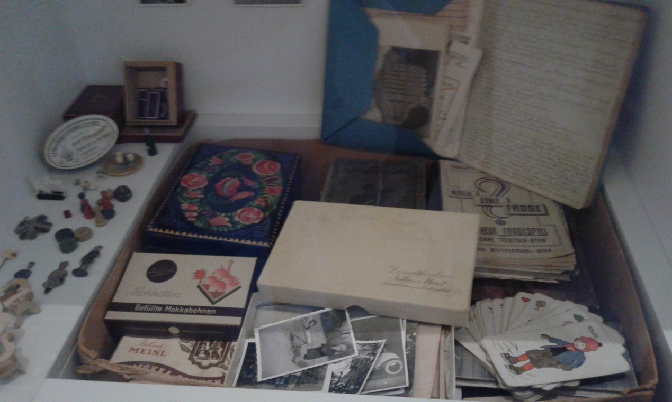
Activity 1:
- What do you think this photo shows?
- Where do you think that these items were found?
- Take a virtual tour at the Jewish Museum of Vienna to find out more: https://www.google.com/culturalinstitute/beta/partner/jewish-museum-vienna?hl=en
- Do you have any of these items in your house?
Time estimated: 20 min.
Activity 2: Watch the film “Lilli Tauber – a suitcase full of memories” and discuss the following:
- Why did Lilli’s parents decide to let her go away with Kindertransport?
- What do you think Lilie got with her for this trip? What would get if you had to leave home for a while?
- Write on posted paper one feeling that you got watching the film and put on a carton. Share your ideas with the rest of the class.
Time estimated: 40 min
Activity 3: Bring to school one of the items that you would choose to take with you and narrate your personal story related to this item. Try to keep your audience engaged!
See what other children took with them in the following photos (Jewish Museum of Berlin)
Time estimated: 30 min
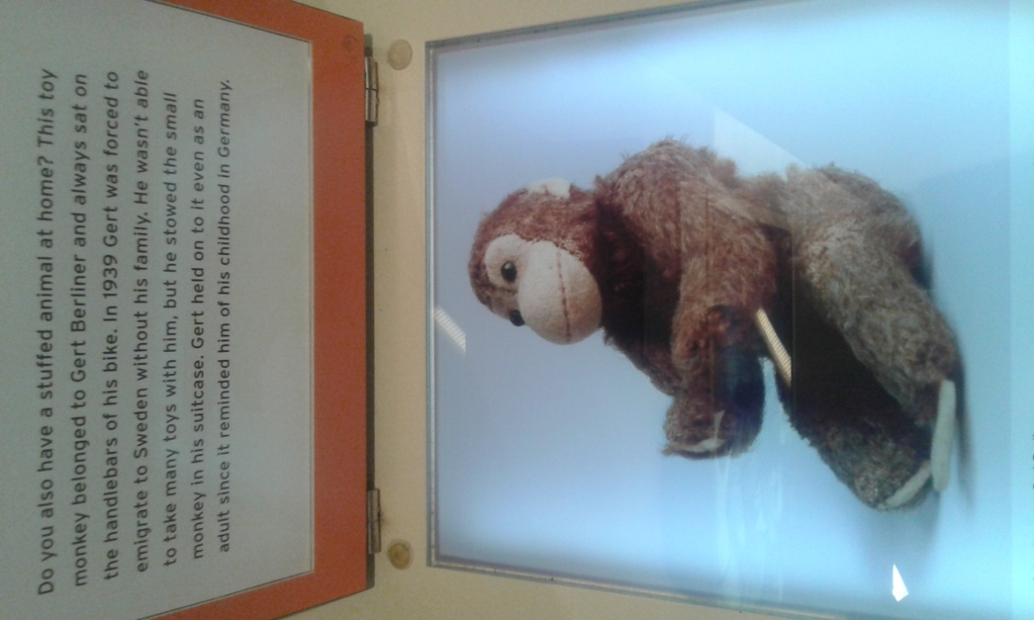
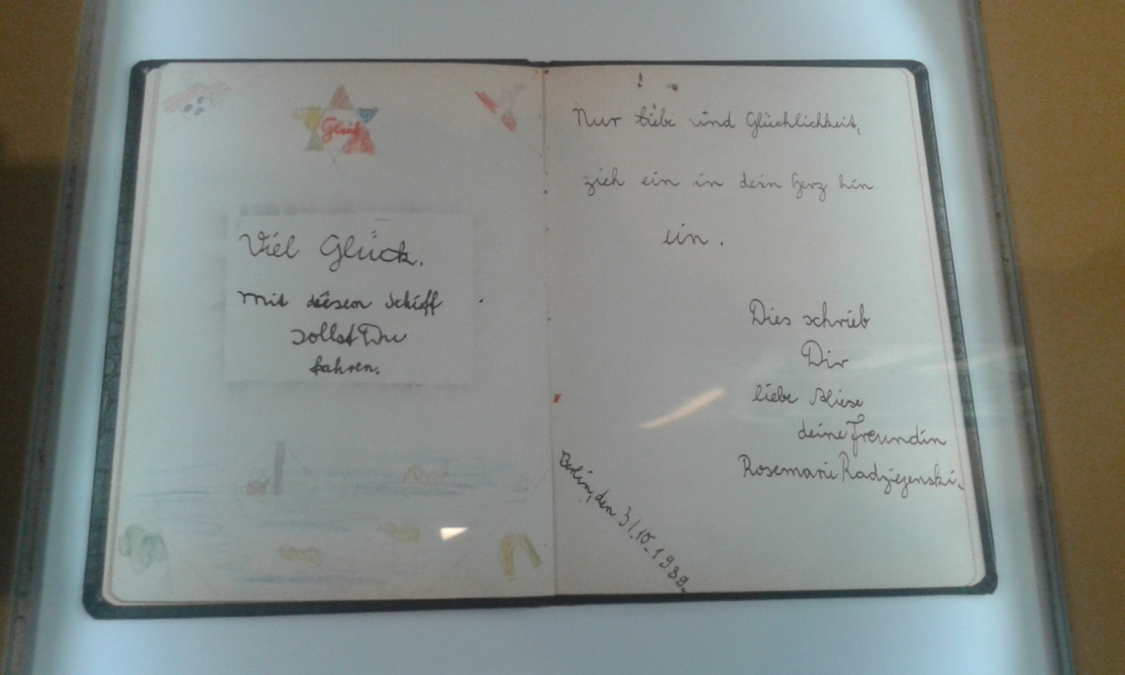
Draw/Create your safety box.
Activity 4: Lilli exchanged letters with her parents. Most of them describe their ordinary life. Do you think that they avoid mentioning some things? If yes, what would you not write in a letter?
Time estimated: 5 min.

Activity 5: Imagine that you need to leave your family and be hosted in another country. Write a letter to them explaining your new life. (Use informal language)
Time estimated: 15 min.
Activity 6: Invite Shelly Kounio, one of the hidden children of Thessaloniki to school to be interviewed by students.
Watch the movie “Kisses to the children” by Vasilis Loules and compare the conditions the two young girls Lilli and Shelly had to live and the way they managed to survive.
Time estimated: 1 hour

