Overview Information
- Lesson Title: The ones that got away….The Kindertransport
- Lauren Piner (South Central High School, North Carolina, USA) and Steve Goldberg (New Rochelle High School, New York, USA)
- Course: World History; Holocaust and Genocide Course
- Category: The Holocaust
- Grades 9-12, Ages 14-18, Can be scaffolded to fit standard-level or honors-level students
- Time Required: two, ninety-minute class periods

Personal Information
Lauren Piner: Lauren Piner has five years of experience teaching primarily Title I students in Eastern North Carolina at South Central High School in Winterville. She teaches a semester-long, ninth grade World History course (both standard and honors-level), and a semester-long Honors Holocaust and Genocide elective. She became involved with Centropa at a winter seminar at Duke University in February 2015. Lauren participated in the Centropa Summer Academy in Poland in 2015 and Vienna, Prague, and Berlin in 2016.

Steve Goldberg: Steve Goldberg has served as chairperson of the Social Studies department at New Rochelle High School for the past 26 years; he is a recent president of the National Council for the Social Studies and he is currently the president of the Westchester Lower Hudson Council for the Social Studies. Steve has been a participant for several years at the Centropa Summer Academy.

Lesson Summary
This lesson provides a brief overview of The Kindertransport for students with an extension lesson that allows students to trace the experience of a child who was a part of the Kindertransport or an adult who was integral in the implementation of the Kindertransport process through Europe. This lesson uses three specific Centropa films, “Only a couple streets away from each other”, “A suitcase full of memories”, and “The story of the Brodmann family”. Included in the lesson are background information and selections from documents located in the Vienna-Jewish Sourcebook published by Centropa.

Context for Lesson

Enduring Understanding

Goals/Objectives

Centropa Sources Used
Vienna-Jewish Sourcebook page 132-133
Films and Interviews: Kitty and Otty Suscheny, Lillie Tauber, Kurt Brodmann

Lesson Plan
- Lesson Opening:
  - As students come into the classroom divide them into two groups.
  - Once students are all in groups begin class by handing each group one photo (Photo A or Photo B)
  - Give students 2 minutes to look at the photo and answer the following questions individually on a sheet of paper.
    - What do you see?
    - What do you think it is?
    - Is there any symbolism?
    - Where do you think this is?
  - Give students 3 minutes to share out in their groups what they wrote with one another
  - Each group elects one representative to share their responses to the photo as it is projected on the board to the whole class. .
  - Once students share their answers, tell students both are photos of commemorative memorials to the thousands of children placed on the Kindertransport
- Teacher will then provide a brief overview of the Kindertransport
  - Give each student a copy of the Overview Handout (page 132-133 in the Centropa Vienna-Jewish Sourcebook
  - While students are reading, they should answer the following focus questions:
    - Who started the kindertransport?
    - Where did it take place?
    - Who got to go? What were the requirements?
    - When did it start? When did it end?
    - Why was it needed? What was happening?
- Teacher and students then go over/discuss their answers to the focus questions
- Once students have a sufficient understanding of the basics of the Kindertransport, students may complete the lesson extension activity
Lesson Extension Activity
- Break students into groups of 2-3
- Once students are paired, hand each group a folder with pertinent documents (Handouts for All, taken from UK National Archives) and documents related to their assigned individual(also include links to Centropa videos for those that apply) and have them trace the experience of a child who was a part of the kindertransport, or a person who was actively involved in its creation/implementation.
- Once students have gathered sufficient information, they will create a timeline poster or Glog to be shared with the rest of the class about their individual in either a presentation or gallery walk format (teacher’s discretion)
- Items to cover/answer/include
  - Children of the Transport
    - How were they chosen for the kindertransport? What was the process?
    - How did they get to their destination? What routes did they take? What was the journey like?
    - Once they got to Great Britain where were they placed?
    - Whom with and where did they live?
    - What did they do during the war? What was life like?
    - What did they do after the war? Where did they end up after the war?
  - Instrumental Individuals in the Kindertransport
    - Who were they? (Where were they from? What was their life story up to that point?)
    - How did they get involved with the Kindertransport?
    - What was their role in the Kindertransport?
    - What did they do during the war, after the Kindertransport was stopped? Where were they?
    - What did they do after the war?
    - Were they ever given any awards for their work?
- Individuals
  - Kitty Suschny (child)
    - Interview
  - Lilli Tauber (child)
    - Interview
  - Kurt Brodmann (child)
    - Interview
  - Samuel Hoare (politician)
  - Viscount Herbert Louis Samuel (politician)
  - Geertruida (Truus) Wijsmuller-Meijer (rescuer)
  - Nicholas Winton (rescuer)
  - Wilfrid Israel (rescuer)
  - Rabbi Solomon Schonfeld (rescuer)
  - Bertha Leverton (child, organizer of the Kindertransport reunion)
  - Else Hirsch (teacher)
  - Hanna Bergas (teacher)
  - Anna Essinger (teacher)

Photo A

Photo B
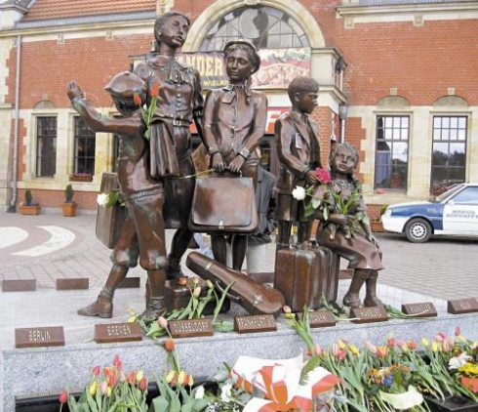
Overview Handout 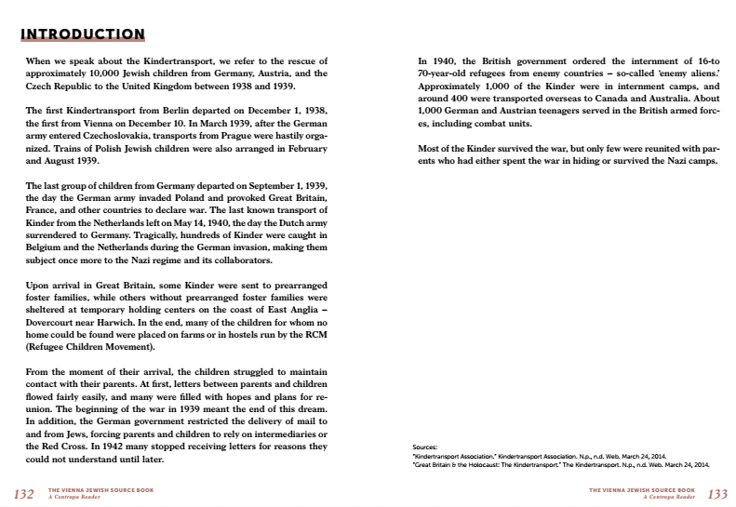

Handouts for all (pg 1 of 2)
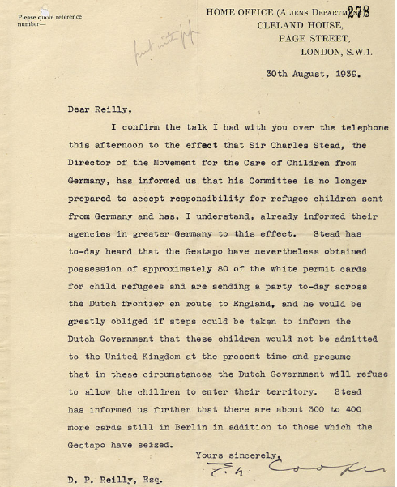

Handouts for all (pg 2 of 2)
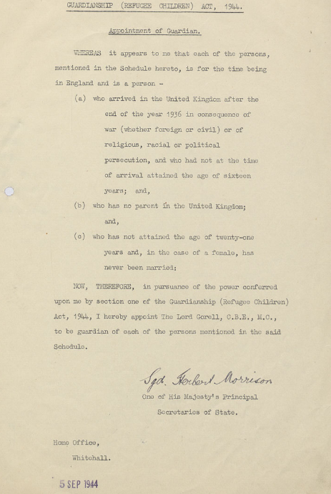

Handouts for All
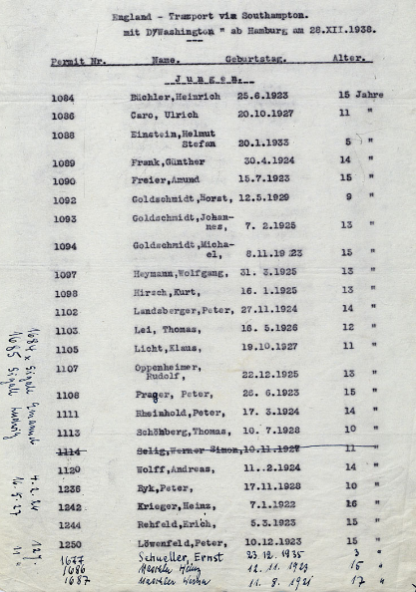

Handouts for All

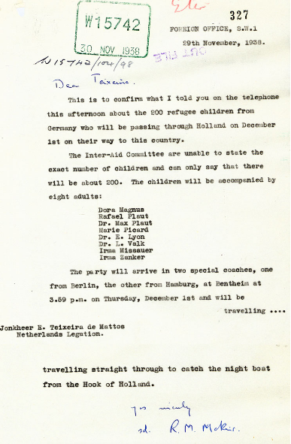

Handouts for All (pg 1 of 2)
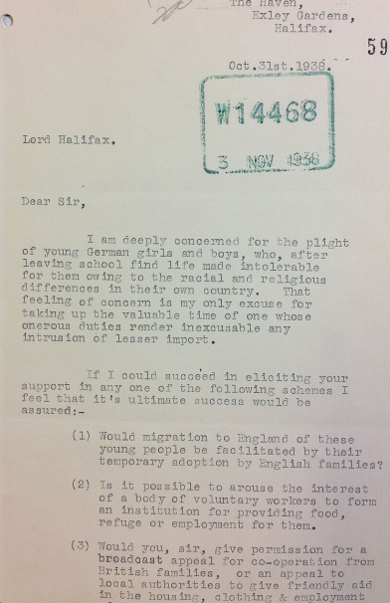

Handouts for All (pg 2 of 2)
