A project based on Centropa's Lilli Tauber film.
Formed by: Martina Dethloff, Germany and Ruthy Shahar-Louck, Israel for 7th graders.
Media: The Centropa film: Lilli Tauber, a suitcase full of memories.
Edmodo platform
Students' mobile phones

The Ones Who Got Away…. An Inter - Cultural Project

Lesson 1: Introduction
How to use the Edmodo platform.
Task 1: 1. Students introduce themselves in a short paragraph (Preferable with a picture)
2. Students respond to at least one post of the other group.
Lesson 2: Opening Activity
Teacher gets up unexpectedly, changes tone and manner of speaking asking pupils to:
1. Put all their cellphones in the basket. 1. Follow (me) 2. Quickly
3. Walk silently
Teacher takes pupils outside to a less known spot at school (previously set up as available) asking them to walk quietly and sit down (preferable on the floor) Teacher keeps silent, offering no explanations, not answering any questions. When seated, teacher distributes paper asking pupils to relate to the following questions: (appendix 1)
1. How did you feel when you were asked to hand in your mobiles with no special reason? 2. How did you feel when asked to leave the classroom not knowing where you are heading? 3. What emotions were evoked when you were asked to sit on the floor?
Teacher asks pupils to follow him/her once again back to classroom.
Teacher asks pupils to list the objects they would choose to take with them in case they have to leave their homes without their parents. (Limited to one hand bag)
Homework: Choose five objects from your list and bring them to class next lesson.

Lesson 3: What would I Take?
Task 2: 1. Put the 5 objects you have brought on the table or on the floor and take a clear picture of them.
2. Upload the picture to the Edmodo platform and write a few sentences about ONE object and why is it so important for you.
3 Relate to at least one post of the other group

Lesson 4: Viewing the film: Lilli Tauber – A suitcase full of memories. (together)
Task 3: 1. Write a few sentences describing what was the most touching/moving part in the film for you? Why?
2. Relate to at least ONE post of the other group.

Lesson 5: Basic understanding
Watch the film once again in pairs (computer room)
and relate to the questions in the following worksheet (appendix 2)

Lesson 6: Bridging text and Context
Teacher brings an informational text explaining what Kindertransports are (Appendix 3). Pupils relate to question: Which information did you already get from the film? Which information was new to you?
Class discussion

Lesson 7: Summing it all up
Teacher presents the question: Nowadays we have many children that come to Europe on their own, as refugees. Imagining the experiences of Lilli Tauber, What do you think can be done to support these children?
Class discussion
Reflection: Students reflect on their own work and process of learning (done individually.) (Appendix 4)

Appendix 1
Lesson 2: Opening Activity

1. How did you feel when you were asked to hand in your mobiles with no special reason?
____________________________________________________________________________________________________________________
2. How did you feel when asked to leave the classroom not knowing where you are heading?
____________________________________________________________________________________________________________________
3. What emotions were evoked when you were asked to sit on the floor?
____________________________________________________________________________________________________________________

Appendix 2
Film: Lilli Tauber - A suitcase full of memories
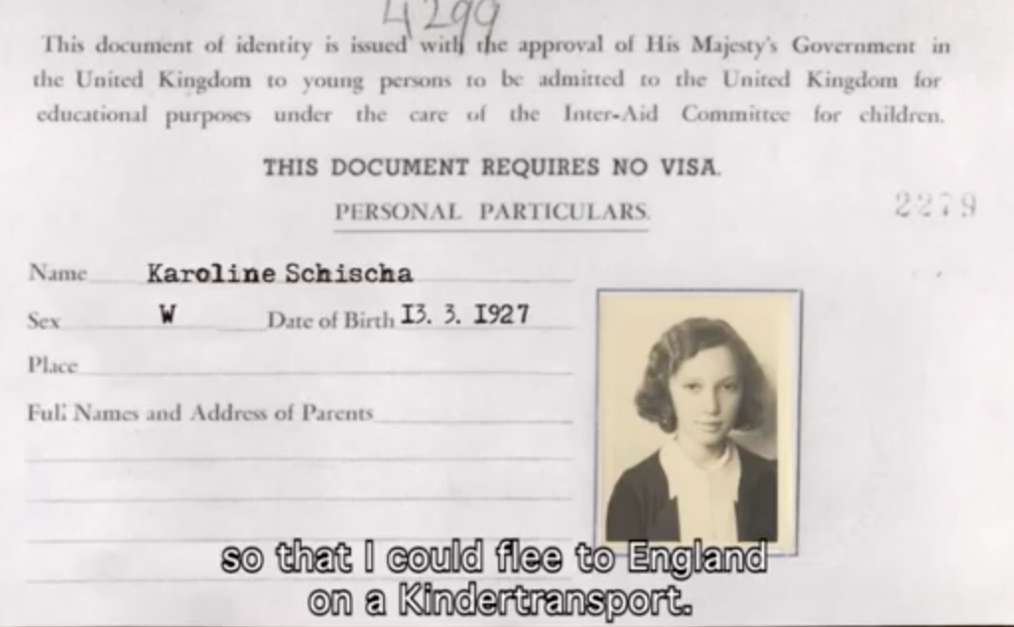

- How does Lilli keep contact with her parents after arriving in Great Britain
_______________________________________________________________________________________________________________________________________________________________________________________________________________
- Where and with whom does she stay in England?
_______________________________________________________________________________________________________________________________________________________________________________________________________________
- Why is the contact with her parents getting more difficult?

_____________________________________________________________________________________________________________________________________________________________________________________________________________
- What does she do to distract herself from the situation she is in and who is giving her and the other refugees support in Great Britain? __________________________________________________________________________________________________________________________________________

- What kind of education does she get? Why?
_________________________________________________________________________________________________________________________________________________________________________________________________________________________________
- What do the parents write to Lilli?
_______________________________________________________________________________________________________________________________________________________________________________________________________________
- What does Lilli write to her parents?

_______________________________________________________________________________________________________________________________________________________________________________________________________________
- What happens to Lilli’s parents after they have to leave Vienna?
__________________________________________________________________________________________________________________________________________ _____________________________________________________________________
- Why is the suitcase she gets from her aunt so precious for her?
______________________________________________________________________________________________________________________________________________________
- How does her life continue after the war?
__________________________________________________________________________________________________________________________________________
Appendix 3

Kindertransport
From Wikipedia, the free encyclopedia
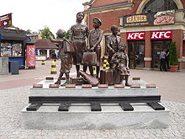
The Kindertransport (German for "children's transport") was an organised rescue effort that took place during the nine months before the outbreak of the Second World War. The United Kingdom took in nearly 10,000 mainly Jewish children from Germany, Austria, Czechoslovakia, Poland, and the Free City of Danzig. The children were placed in British foster homes, hostels, schools and farms.
Frank Meisler's Kindertransport memorial (2009) at the Gdańsk Główny railway station in Poland.

Often they were the only members of their
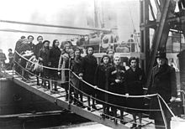
families who survived the Holocaust.

On 15 November 1938, a delegation of British Jewish leaders asked the Prime Minister of the United Kingdom, Neville Chamberlain that the British government permit the temporary entrance of unaccompanied Jewish children, without their parents.
Arrival of Jewish refugee children, port of London, February 1939

The British Cabinet consulted the Parliament and finally decided to accept into Great Britain unaccompanied children from little children up to the age of 17. At first, the Jewish refugee agencies considered 5,000 as a realistic goal. However, after the British turned down the Jewish agencies' request to allow the entrance of 10,000 children to British-controlled Palestine, the Jewish agencies then increased their planned target number to 15,000 unaccompanied children to enter Great Britain in this way.
The organization who has taken care of the children was called the Movement for the Care of Children from Germany. This organization was considering only the rescue of children, who would need to leave their parents behind in Germany.
The agencies promised to find homes for all the children. They also promised to fund the operation and to make sure that none of the refugees would become a financial burden on society.

Appendix 4
Personal Reflection
What was the most difficult part for you, working on this project?
__________________________________________________________________________________________________________________________________________________________________
What did you enjoy the most?
__________________________________________________________________________________________________________________________________________________________________
How did you feel about having to contact a teenager your age from Germany/Israel?
__________________________________________________________________________________________________________________________________________________________________
Thank You!

