Rosh haShana: Gefilte fish recipe.
(done by joel): Gefilte in Yiddish ( a foreign language speaken by the ashkinaze jews in the 1900 – century) means ’stuffed’ and the meal it self, is a big ball of stuffed fish, it’s also often served with served carrot on top (as shown on the picture). You usually use whitefish, carp or sometimes even pike.

INGREDIENTS
- 2 quarts (8 cups) fish stock
- 1 cup large-dice yellow onion (from about 1 medium onion)
- 1/3 cup peeled and large-dice carrot (from about 1/2 medium carrot)
- 1/3 cup peeled and large-dice parsnip (from about 1/2 medium parsnip)
- 2-1/2-pound mix of skinned white mild-flavored fish fillets, such as cod, halibut, pike, or grouper
- 1/3 cup matzo meal
- 3 large eggs, lightly beaten
- 1 teaspoon packed, finely grated lemon zest (from about 1 medium lemon)
- 3 tablespoons freshly squeezed lemon juice
- 4 teaspoons kosher salt, plus more as needed
- 1/2 teaspoon freshly ground black pepper, plus more as needed
- Beet Horseradish or Dill-Horseradish Mayonnaise, for serving (optional)
INSTRUCTIONS
- Place the fish stock in a large, wide stockpot and bring to a simmer over medium heat. Reduce the heat to medium low and maintain a low simmer.
- Place the onion, carrot, and parsnip in a food processor fitted with a blade attachment. Process until the vegetables are very finely chopped, stopping to scrape down the sides of the bowl as needed, about 1 minute total. Transfer to a large bowl and set aside.
- Cut the fish into 1-1/2-inch pieces. Place half of it in the food processor and process until a ball has formed, about 30 seconds. 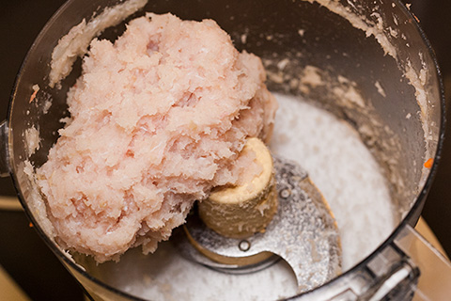 Transfer the ball to the bowl with the vegetables and repeat with the remaining fish.
- Sprinkle the fish mixture and vegetables with the matzo meal. Add the eggs, lemon zest, lemon juice, and measured salt and pepper. Using clean hands, mix until combined (don’t squeeze or overwork). To taste for seasoning, form a small patty and poach it in the fish stock until firm and cooked through. Taste the patty and add more salt and pepper to the fish mixture as needed. Repeat the seasoning test as needed.
- Using wet hands and a 1/4-cup measure, form the fish mixture into 3-inch-long ovals. 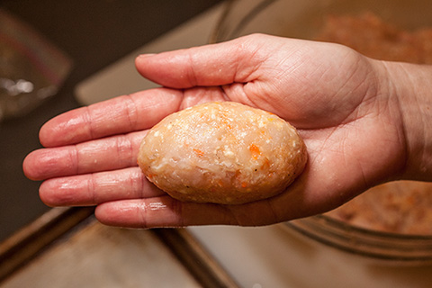 Place on a baking sheet.
- Gently place the ovals in the simmering stock. 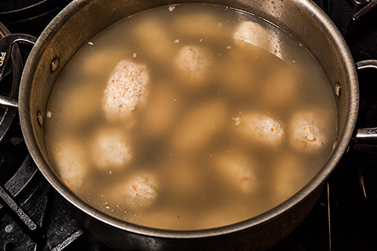
- Cover with a tightfitting lid and simmer until firm and cooked through, about 10 minutes. Using a slotted spoon, carefully remove the ovals from the stock and transfer to a clean baking sheet to cool.
- Pour the stock through a fine-mesh strainer set over a large heatproof bowl, discarding the solids. Allow the stock to cool to room temperature.
- Meanwhile, place the cooled gefilte fish in a large container with a tightfitting lid and refrigerate. When the stock is cool, pour it into the container with the gefilte fish, making sure they are submerged. Cover and refrigerate at least 1 hour and up to overnight.
- To serve, use a slotted spoon to transfer the gefilte fish from the stock to a serving platter. Serve with beet horseradish or dill-horseradish mayonnaise, if using.
And done! Served with usually on jewish holidays for instance Pesach and Rosh haShana!

Hebrew part (done by Michelle): רוש השנה
ברוש השנה המשפחות שלנו אוכלים חלה עגולה ותובלים את התפוח בדבש.
אנחנו אוכלים חלה עגולה כי השנה עגולה, אנחנו אוכלים התפוח עם דבש כי התפוח גם עגול והדבש מתוק. אוכלים תפוח ודבש בשביל שיהיה לנו שנה מתוקה.

זהו מתכון לחלה עגול,אתה צריך:
קמח,שמן זית,ביצים,שמרים,מלח,מים וסוכר.
ממיסים את השמרים במים חמים
לאוסיף את הקמח ולערבב
לאוסיף את שאר המצרכים ולערבב
את הבצק צריך לעשות בצורה עגולה
מניחים את הבצק בתנור ב150 מעלות 20 דקות

אנחנו מאחלים לכם הצלחה ושנה טובה.

נכתב על ידי מישל.
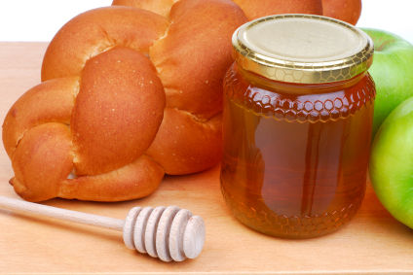
Swedish part (done by Ben):
TRADITIONER OM ROSH HASHANA MATRÄTTER

Gefilte fish är en klassisk judisk maträtt som många judar äter på Rosh Hashana middagen.
Gefilte fish är gjord av fisk, oftast karp, sik eller gädda.
Gefilte fish kommer från den ashkenaziska kulturen och man äter det på många judiska helger som Shabatt, Pesach och Rosh hashana.

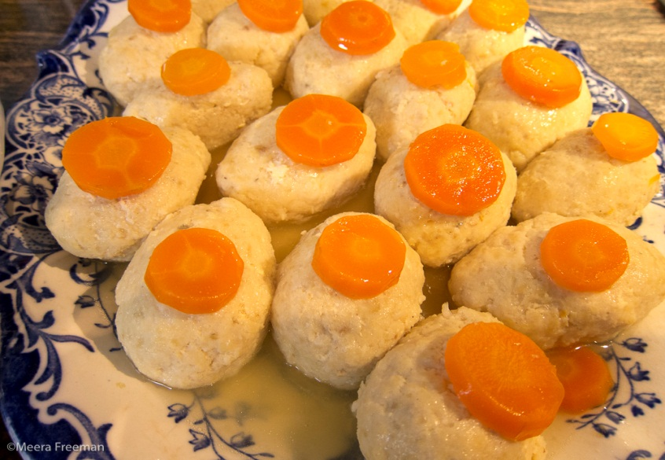

En annan Rosh Hashana tradition är fiskhuvudet, man har fiskhuvudet på Rosh Hashana middagsbordet som en symbol för att man ska vara ledaren (huvudet leder) och inte svansen (svansen är följaren).

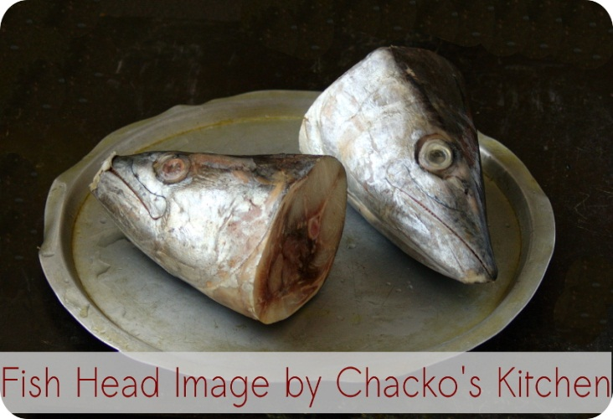

Man har även runda challot för att året är runt.

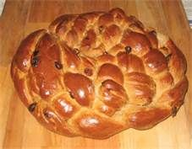

Man brukar doppa chalan i honung och det symboliserar att det ska bli ett sött och gott nytt år.

Äpplen är även en populär Rosh Hashana tradition, man brukar doppa äpplet i honung för att det är runt och att det ska bli ett bra år. Man har även äpplen för att det är var en exotisk frukt förr i tiden och att de bara växte bra under den tid Rosh hashana är.

