My Family History and My Roots: A Film Project
Student Project Guide 2018
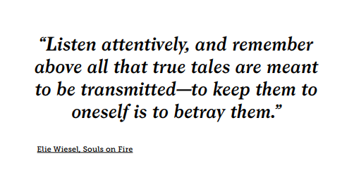
Introduction
This year, for your Roots Project, you will create a film that focuses on either of the following:
- the life of an older family member
- a film that traces your family history through several generations and ends with you (if you like).
Your final project will be in the format of a digital film. It will be a blend of family museum, historical archive, family album – and, hopefully, with dedication and imagination, it will turn out to be a genuine tribute to your family and to members of your family.
We will discuss details in the guide, but, in a nutshell, your film will have what all films have: visuals and text - images, music, narration of a text, and a film script that you will write.
To create your Roots Family History film, we will be tapping into all the resources available to you, but we will also frequently refer to the website of Centropa, the historical institute dedicated to preserving 20th century Jewish family stories from Central and Eastern Europe and the Balkans, as well as Greece, and Bulgaria.
Centropa is also an educational institution, as its resources, stories, films, and interviews are directed towards students and teachers with a clear eye towards the classroom and the greater world of education.
Naturally, we will be using a variety of sources to gather our information, but as models for your film, we'll be turning to numerous biographical films on the Centropa website. We will not only use the films as models to study the technical aspects of making such family films, but we'll also view them because so many of them tell compelling, interesting stories. Our own engaging with the people in the films - their lives, their hopes, their choices, and their fates – should be of great help as we shape our own stories and films for others to see.
There is a great deal on the Centropa website that can help guide you through the process, and there is no question that it can prove to be a very “useful tool”. Its information and resources, as noted before, can serve as a wonderful model for your own project, and I recommend that you refer to the website as much as possible.
There is much more on Centropa and its website in the sections that follow below.
For now, take a brief tour: http://www.centropa.org

Getting started
Collecting information from your family
Before you start planning your film, you have to gather a wide variety and a great deal of source materials that we will sometimes refer to as “documents” and “documents of all kinds”. You may need a good deal of help from the “older generation” – parents, grandparents, aunts, uncles, cousins. Ask anyone and everyone for help because they probably know more about your family than you do and have access to more information as well. Ask as many questions as you need to ask of anyone you can.
Documents and source materials
- ALL kinds of photos: family and friends, everyday events and activities, friends, class photos, houses, graduation pictures, wedding pictures, traditions, holiday celebrations, vacation pictures, shopping, markets, nightlife, leisure activities, work, school, military service, memorials, headstones, monuments
- Locations: cities, towns, villages, rural areas, lakes, rivers, countryside, fields, farms, etc.
- Official Certificates: birth certificates, marriage certificates, military certificates, property deeds, employment certificates
- Diplomas: high school, special courses, college and university, vocational, professional
- Awards, medals, citations, commendations, etc., from military and civilian life
- Travel documents: passports, visas, laissez-passer, immigration certificates, exit visas, etc.
- Identification documents – personal IDs, military IDs, property deeds, documents of ownership
- Personal family letters, diaries, albums, invitations, announcements
- Personal collections that tell something about a person: stamps, coins, toys, etc.
- Others: ________________________________________________________________
_______________________________________________________________________
Notes on Scanning images
For the project, scan the photos and documents and save them for later (and perhaps, even, multiple) use. When you scan and save the photos and documents, give them names or coded numbers so you will know where, when, and how to use them in the film.
Remember, it is important to take high quality photos and/or make high resolution scans that will look crisp and sharp when they are inserted into your film.
Keep in mind that the more a photograph, document, certificate, etc. is enlarged, the more it loses resolution and sharpness. Naturally, when the film is projected for audience viewing, this could impact upon the quality of the images in the film they see.
If a scanner is not available, scanner apps are now available for smartphones. By scanning instead of photographing, the entire document will be in focus - if done carefully.
Using a smartphone camera
If you use a smartphone camera to take photos, be sure not to create shadows. In addition, the photo should not be taken at an angle, otherwise part will be in focus and part won't because of the depth-of-field issue.

Further information
You will have to gather a good deal of information about your family or about a person who will be the focus of the film.
Look at the chart below. Use this one or make your own and just brainstorm words, terms, names, places, etc. – whatever comes to mind – just to get the process going and the ideas flowing. (You will probably need to make the chart larger.)
What do I already
know about the subject?
What more would I like
to know?

Refer to the source materials section above: Ask about family and friends, everyday events and activities, routines, foods people ate and foods they ate on special occasions, school activities and school life, subjects studied in school, graduation ceremonies, wedding events, bar mitzvah and bat mitzvahs, family traditions and customs, holiday celebrations, vacations, sports activities, business activities, leisure activities, hobbies, military service, the origin of your family name and what it means, how your family got its name.
The Interview: Focus on a family member
If the focus of your film is on one family member, try to interview that person.
Devise a set of questions or a questionnaire that you will then use to interview a member of your family. In this way, you will find out specific information about your family and its history that you can use for the script of your film. Use ideas from the brainstorming, “Getting acquainted with the project topic” section. Try to prepare at least 10 questions.
When you interview the person, remember that sometimes the person's answer to a question may lead you make up another one on the spot. Let the interview flow. New questions sometimes come right from the answers to previous questions. Be open to this and don’t stick solely to the original list of questions.
For example, if one question says, "What sort of games did you play?", the next question should not be "Where did you go to school?" but should flow from that answer. In other words, use the answer to the question about games to ask additional questions about games – who played them, boys, girls, what ages, what was needed, where were they played, etc.
Also, be patient and give the interviewee time to answer your questions.
Your film should eventually show photos and images of the interviewee. In that way, the person comes alive for the film viewers and what we have learned about the person and your family now has a very personal face.
Remember, the film is not an interview and so we will not see the person sitting there talking throughout the film. The film may have photos of the person you through time, but the purpose of the interview is to gather information and to recreate a story, a story of a childhood, of growing up, of adulthood.

Family information to include in your film
Before we can understand the “drama”, we must create the stage where the drama takes place. This involves looking at the historical, political, socio-historical, and socio-economic situation of the places from where your family came.
First of all, you will also have to carry out some research about the nation, region, or community from where they emigrated. You need NOT include an extensive history of the place, but instead paint a picture of what life was like there and how conditions might have persuaded your family to leave and immigrate to Israel.
Next, for a more personal look into understanding why your ancestors left places where they had been living for a long time, you will have to ask your own family members questions. Again, refer to the areas and subjects in the source materials section above.

Gathering Information and Conducting Research
You will also have to conduct some general research for the script of your film. The Internet has an abundance of resources to help you find information. I can recommend several that I think are outstanding for our project.
CENTROPA has digitized 22,000 photos and has made more than 40 multimedia films that are available for viewing. As you may not have personal family photos you would like to use to show a town, city, village, market, modes of transportation - ocean liner, railroad, automobiles, horses and wagons - famous persons, famous events – go to the Centropa website and conduct a search.
If you don’t have an old photo of a town or city back in, say, the 1890s, or the 1910s, or the 1930s, and you feel it really belongs in your film, try the Centropa website. Then use your screen capture program if you come across a shot you would like to keep. (The Snipping Tool, available in Microsoft Windows, also works well.)
YAD VASHEM is the world’s most well-known site for information, resources, and photographs related to the subject of the Holocaust and Jewish life in Europe prior to the Holocaust.
The archives at Yad Vashem contain the largest collection of Holocaust documentation in the world: 125 million pages of documentary evidence, films, 420,000 photographs, and more than 100,000 survivor testimonies.
In addition, the library at Yad Vashem comprises over 112,000 titles in 50 languages of Holocaust-related publications and a collection of about 4,000 newspapers and periodicals, many from the Holocaust period.
The site is comprehensive in its scope, rich in its information, and user-friendly. Log on here: http://www.yadvashem.org
Another excellent source of information is the website of the UNITED STATES HOLOCAUST MEMORIAL MUSEUM, located in Washington, D.C. You can log on here to access a wide variety of historical background, information, and photographs about Jewish life in Europe before WW II and, of course, during the Holocaust: http://www.ushmm.org/
The website of the JEWISH VIRTUAL LIBRARY states that it is “the most comprehensive online Jewish encyclopedia in the world, covering everything from anti-Semitism to Zionism. There are more than 16,000 articles and 7,000 photographs and maps that have been integrated into the site.” The large offering of maps is available and could prove to be very useful to you. This is the website: https://www.jewishvirtuallibrary.org/

BEIT HATFUTSOT - the Museum of the Jewish People (in Tel Aviv) and MyHeritage.com have collaborated on a major project to preserve Jewish family trees. For three decades, Beit Hatfutsot has been collecting digital information on many topics, all aimed at preserving the history of the Jewish people.
Its multimedia database includes genealogy, histories and meanings of surnames - over five million individuals have already been recorded in the ever-expanding database - communities, historical photographs, film, video, and music. The museum has also focused on the histories of particular Jewish communities and, for example, in 2016, there was an exhibition about the Jewish Communities of Austria from the Middle Ages, to the Modern Era, to the Contemporary Era, which included personalities, daily lives of ordinary people, and the city of Vienna. https://www.bh.org.il/
Check out the website http://tracingthetribe.blogspot.com/2009/12/saving-trees-myheritage-beth-hatfutsot.html - "Tracing the Tribe: The Jewish Genealogy Blog". Have a genealogy question? Send it to ask@tracingthetribe.com
Finally, there is a little-known treasure close to home, right here in Jerusalem – the NATIONAL LIBRARY OF ISRAEL. Information is available in Hebrew, English, and Arabic and among its offerings are the library, the collections, e-resources, a digital library, an education department, and a music collection. The website is http://web.nli.org.il/sites/nli/English/Pages/default.aspx
The screen shot that follows shows a portion of the Homepage of the National Library of Israel. Scroll across these headings for a more complete description of each.
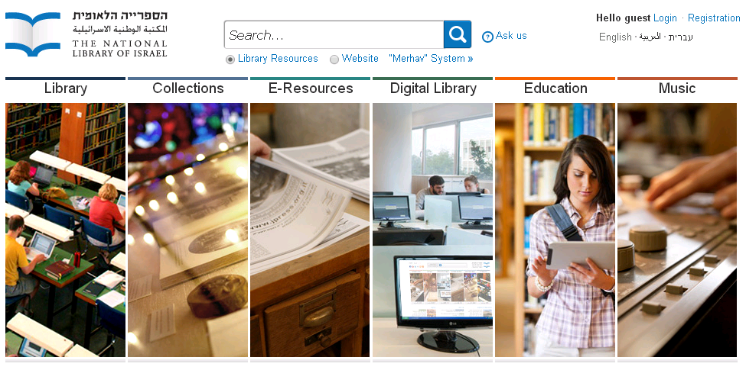
The library has a very large collection of historical photographs available about Israel's early pioneering days, the founding of communities and towns, the Mandatory period, independence, and up to the present day. The collection runs the gamut of cultural images and images of everyday life.
In addition, the library also has an extensive music collection if you wish to use older music and songs as background soundtracks to illustrate specific village, town, and kibbutz scenes or to compliment historical events with music.
The website is available in three languages – Hebrew, English, and Arabic, though the latter two are not yet as fully developed (i.e., translated materials) as the Hebrew site is.

MAPS
Maps provide us with an initial understanding of where events took place – where they began, where they played out, and where the events of people’s lives took them. Maps provide a picture of the "stage" on which historical events began and how they continue to unfold to the present day. Maps help trace family lives - where people were born, grew up, were educated, moved to, returned to (in cases), or where they finally settled and lived the rest of their lives.
Your film must include maps that are significant to your story and that show where events in your family took place. Also include maps that show where your family originated as well as places where they might have moved. Trace the routes of their journeys within those places as well as routes of emigration from and immigration to other lands in the course of your film. Finally, include maps in your project that trace your family's route(s) to Israel (or other places in the world), where they moved around within Israel, and where they finally settled.
The Internet has numerous sites for you to locate maps – current and historical. Be careful here: Use websites for historical maps, so when you show the origins or journeys of your family or a family member, say, back in Germany in 1932, in Poland in 1938, or in Libya in 1948, your maps are accurate reflections of how those nations looked during the years you’ve indicated.
To be honest, this is one reason why you should avoid using only Google maps, because they are present-day maps. Yes, I know, they are digital, convenient, and readily available, but they are historically inaccurate for your purposes – and you want to aim for historical accuracy.
You'll notice that maps are important features that appear throughout Centropa films.

Using your materials
Remember the scans? Remember all the personal material you have on hand?
- Remember all the “documents” of ALL kinds, all the photos of people - friends and family, everyday events and activities, class photos, vacations, houses, graduation pictures, wedding pictures, vacation pictures, shopping, markets, nightlife, leisure activities, photos at work, at school, military service.
- Remember all the certificates - birth certificates, marriage certificates, military certificates, property deeds, employment certificates.
- Remember all the diplomas - high school, special courses, college and university, vocational, professional.
- Remember all the travel documents – the passports, visas, laissez-passer, immigration certificates, exit visas, etc.
- Remember all the identification documents such as work IDs, military IDs along with other types of documents such as property deeds and documents of ownership.
- Remember all the awards, medals, citations, commendations, etc., from military and civilian life.
- Remember other photos you can use to show location – cities, towns, villages, lakes, rivers, countryside, fields, farms, ports, harbors, monuments, memorials, cemeteries, etc.

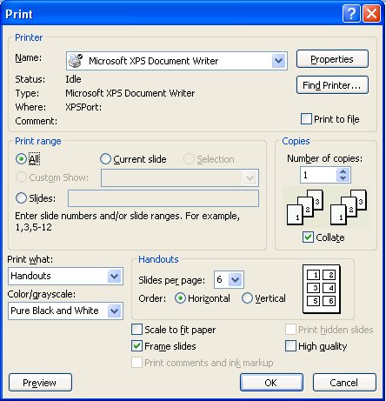
Making your film
Planning
Just as animators, cartoonists, and storywriters do, begin by creating a storyboard. Make boxes and sketch out or write what you would like to have in each scene.
Write instructions, directions, and notes for yourself about each scene. You can draw a chart with boxes or you can use PowerPoint to do this. Using the Print command, you can place multiple slides (4-6) on a page as Handouts and print them out. using Pure Black and White.
Writing the text and script
Gather all your photos, documents, maps in one place (one folder) and think about how you want your story to look. Place them in the order you think you would like to use them as you create the film.
Now, it’s time to start writing your script, using the resources and materials at hand – both from your family and from all the research you have conducted.
Keep in mind that you are telling us a story. The photos, images, maps, and all other visuals you use in the film are really there to “serve” the story line.
In previous sections of the project guide, we’ve talked about what kinds of subjects, topics, and areas to include in the text.
Also consider that history and the lives of the people in your family have a direct connection to one another and what happened in history influenced the “timeline” of the events in your own family’s history. In many cases, these events may have changed the life of your person, the lives of your family, and the paths in life they had earlier charted out for themselves.
Be sure that your film reflects important events that took place in the world or in your family’s town, city, region, or country.
Remember when you write your script, take some time to reflect on all the information and material you have collected. Sit down and look at everything. Take it all in. Take time to reflect and wonder. Keep in mind that the film you are creating and the script you are writing is their story but that most of all, it is also YOUR story.
Avoiding "Information overload"
There is a temptation, sometimes, include as many names, dates, and details in your script and in your film as possible. Be careful – do not "overpack" your film.
This is especially relevant when it comes to names of your family members and ancestors. Too many names can confuse the viewer, especially when we include this brother-in-law, that great uncle by marriage, this third cousin, and so on, so much so that, as we say, you can't tell the players without a scorecard. Think about this when you include the names of places as well. Does their inclusion in the film script help the film?
Of course, if you like, you can have an "animated" family tree or chart where names appear one at a time and where we do not have to process the relations and connections of an entire family all at once. Include names and people, yes, by all means, but ask yourself if they are relevant to the story and if including them serves your purpose. Again, avoid "information overload".

Avoiding "Image Overload"
Again, the script guides the text of the film and determines when pictures appear on screen, when they fade, when new ones appear, and so on.
Be careful: You do not have to illustrate every sentence, every line, or every event in the narrated script with an image taken from the Internet. Sometimes, these seem to fit the text, but they have no serious connection to the story. This could easily lead to "image overload".
We are looking at each family history film for the first time, and we need to carry out several "tasks" at the same time – follow the story, read the subtitles, figure out who's who, and understand the connections between people, places, and events. At the same time, we also need to process changing images and quickly understand how they are part of the story.
We want our viewers to concentrate on the story, on the narration, and on the content without too many images that could distract us.
Instead of inserting too many pictures and images - "image overload" - stay on one, zoom in zoom out, and let the subtitles and narration of the story guide the viewer.
There is a lot of content in each image and you should allow your audience to see what's there. Images serve the story – they are not the story themselves. It is perfectly alright to have an image on the screen for some time. Let your images fade in and out and when you want to show a new image create a smooth transition to the next image. It's restful to the eyes and your viewers will be able to follow the story.
Important points about subtitles
When you begin making the film, place your subtitles on the bottom of the screen, just as you see in films and on TV. Proofread the writing. Spellcheck the writing.
Try to keep subtitles on no more than two lines. If needed, simply go to the next screen to continue, keeping the same image on the screen if it's relevant.
You want your viewers to be able to read the subtitles.
Be sure that the subtitles appear on the screen and remain there long enough for someone to read. Read the subtitle twice yourself – that should give your viewer extra time to read the text.
Avoid fonts that are too difficult to read. Make them large enough to see and read, as many people in your audience will rely on them in the event they can't follow the audio narration quickly enough.
Note the background image where the subtitles appear. Sometimes, subtitles might be set against light backgrounds and sometimes against dark ones. White subtitles will be impossible to see in the former case and black subtitles will be impossible to make out in the latter case. One way of adding clarity and visibility to the text is to give the font a shadow. Try it. But always, in the back of your mind you should be asking: "Can the subtitles be read, and can they be read easily?" Repeat this to yourself as well: "I want my viewers to be able to read what I wrote. I want them to understand my film, enjoy my film, and maybe, even be touched by my film."
Again, remember that the text of the script – your subtitles - enables your viewers to follow your story as they read and as they alternate between reading, listening, and viewing.
Proofread and Spellcheck ALL OF YOUR WRITING – especially the subtitles.
A thought
Remember that, in some way, who you are is also because of who they were, who you are is because of what they believed, who you are is because of what they did, and who you are is because of what they wanted for their lives and for the lives of their children and grandchildren. Try to convey this sense to your viewing audience.
In some way, you may be asking, “Who am I because of who they were?”

Some documents that can help you get organized
- "A Film Project Chrono-Organizer" (chart that helps you place events in chronological order, where the events took place, who was involved.)
- "Resource and Materials Checklist for the Roots Family Film" helps you organize materials and information
- "Organizing the Script and Planning the Film" (two-column planning chart helps you synchronize the script with images, music, audio, narration)
- Final Check – "Roots Family History Films - Final Checklist"
In the boxes, check the documents you need, have received, or have used.

Creating Your Roots Film Using the Centropa Website
CENTROPA: http://www.centropa.org/
More About Centropa
Centropa is a Jewish historical institute dedicated to preserving 20th century Jewish family stories from Central and Eastern Europe and the Balkans. The organization is headquartered in Vienna and has offices in Budapest and Washington, D.C.
Centropa’s banners say, “Preserving Jewish memory - Bringing history to life” and “Where Jewish history has a name, a face, a story”.
The website of Centropa is outstanding. It is both comprehensive in its scope and extremely rich in its information. It is very user-friendly and easy to navigate as its goal is to make its stories, photos, films, and interviews readily accessible to students and teachers. Its website comprises 1,200 interviews, 22,000 digitized photos, and 40 multimedia films.
Centropa’s website has programs, films, biographical information, photographs, and more available in English, Hebrew, German, Czech, Slovak, Bulgarian, Hungarian, Polish, Lithuanian, Russian, Ukrainian, and Romanian. It is a treasure trove of information.
Among Centropa’s aims are to connect students and teachers to the lands of Jewish heritage by creating programs about the entire 20th century – and not only about the period of the Nazi Germany and the Third Reich. Centropa wants to focus on and celebrate Jewish life - and not simply on the Jewish tragedy – as witnessed and so well-known during the Holocaust. Centropa also combats anti-Semitism and Holocaust denial by creating programs that students carry out themselves and share with other students worldwide.
Centropa holds an annual summer academy for educators from Europe, North America, and Israel and they are usually attended by upwards of 90 teachers from approximately 15 or more countries. Teachers work together on many topics and projects during the summer academy and continue to work together, along with Centropa, after the seminars and the summer academies. To date, Centropa has 600 partner schools in 16 countries.
In addition, smaller regional Centropa seminars are held during the school year in Europe, the United States, and in Israel. These seminars also bring teachers together - to work together, to share together, and to create together.

Navigating the Centropa website
Visit the Centropa website to become familiar with the abundance of resources and materials it has to offer. Scroll across the Menu bar, and then open each of the following topics: CENTROPA INTERVIEWS, FILMS, EDUCATION, to see what is available. Each one has a drop-down menu that takes you to a wide variety of subject matter and sources - films, interviews, biographies, etc. As on good websites, you have many links to other subjects and topics found on the Centropa site.

Try this. Click on EDUCATION.
The drop-down menu shows you three areas.
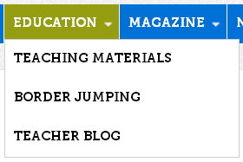

Now click on TEACHING MATERIALS to see what’s available.
The screen capture below shows you all the topics, themes, sources, etc. available in TEACHING MATERIALS under EDUCATION. Have a look through it just to see what you can access on the Centropa website.
Note that this particular screen capture also shows where you’ll be able to find information and instructions to help you create your Roots film.
(We will discuss more about accessing Making Movies a bit later.)

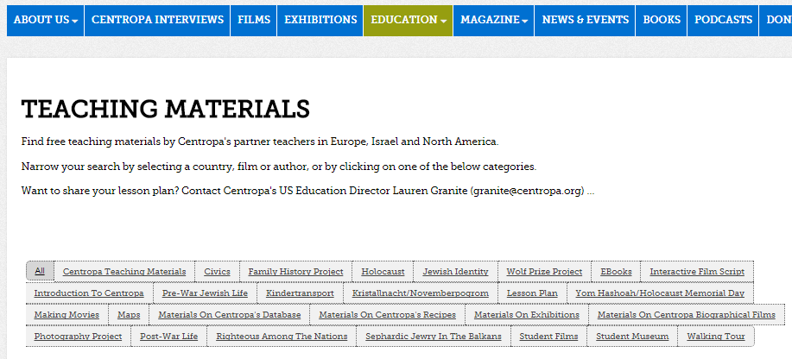
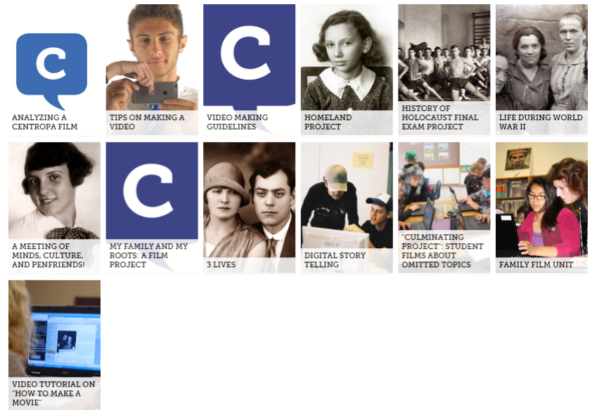

More About Navigating the Centropa Website: Centropa Films
Close-up: Finding films according to themes, events, or people
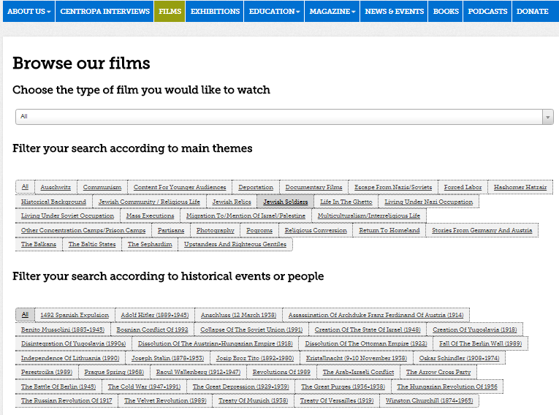

Viewing Centropa Films
It would be a good idea to select and view at least four Centropa films to get a feel for how you might like yours to look.
Many Centropa films focus on one or two people but as they tell their story, naturally, other people become involved and are also included in the story. These people are usually relatives and family members who raised them, who educated them, who guided them, and who instilled values and traditions in them. But there are also friends and acquaintances, teachers, employers, officials, people who helped them, and – yes – in some cases, even people who saved them.
Look at the screen capture that follows, showing the Centropa site where you can access 40 multimedia films.
You can also access the films using this URL: http://www.centropa.org/centropa-cinema
Look through the thumbnails of films on the site and select one to start off. You have a number of viewing options available and, in cases, you can select a language in which to listen to the narration of the film and a language in which to view the subtitles.

Try this. Click on the thumbnail, Maps, Central Europe, and History, seen in the screen capture below.

The screen below appears.

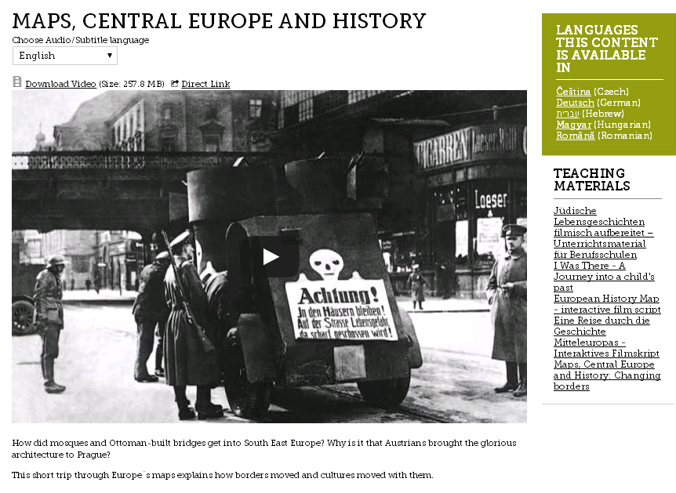
The information in the upper right-hand corner (green box) tells you the languages in which the film is available.

The field shown in the in the red circle in the upper left of the screen capture also allows you to choose several languages in which you can listen to the film or read along with the subtitles. Try it.
If you click on the down-arrow, the choice of languages for audio and subtitles opens. Try it. A close-up of the field appears below.

Here's another example of a film on the Centropa website, "SURVIVAL IN SARAJEVO -- FRIENDSHIP IN A TIME OF WAR".
You can listen to the film in any one of eight languages and view the film with subtitles in any one of seven languages.

In addition, there is an introduction to the film, and off on the right side, for teachers, a hyperlinked list of Teaching Materials that can be accessed for lesson plans.
Below each film are details about the film, length of the film, and countries mentioned in the film.
Finally, there is a study guide and a film script for those who wish to read the script without viewing the film.
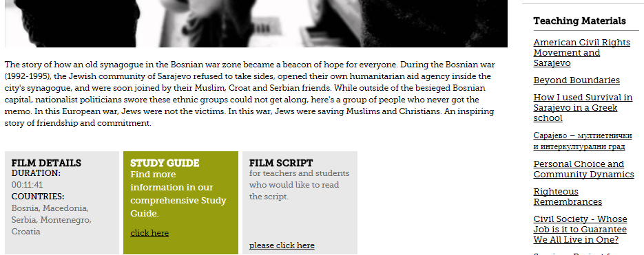

The Great Centropa Treasure Hunt
This Treasure Hunt is a hands-on introduction to the Centropa website.
There is a wide range of questions in the treasure hunt and finding the answers requires a careful search through the website, looking for key words, terms, names, places, photographs, events, etc.
As you answer the questions, you will have to navigate the website, which in turn will help familiarize you with all Centropa has to offer as you set about to work on creating your own film.

Viewing Centropa Films to help create your own
As you view Centropa films, listen to the story. Try to become involved in the person’s life, who she or he is, who was important to them, what happened to them, what they learned in life, and what you can learn from them.
At the same time, take notes and make your own observations not only about the facts of the story, but also about the techniques used to make the film and the subjects, topics, and events that were included in the film.
In a nutshell, viewing Centropa films helps us become familiar with how
- a film biography is written
- it is depicted in film
- it is narrated
- visuals, images, and movement are used
- music enhances the story and mood
- sound effects add “color”

First, make a note of how the filmmaker used scans and images of the “materials” in the film.
Look at how the filmmaker varied the scenes, used motion, moved pictures, made pictures and visuals fade in and out, etc. used music to create moods, to highlight events, or to provide background. (I can make some recommendations for music, though I am certain you have many songs of your own from which to choose.)
Look at how quickly or slowly visuals and images changed, and which ones were left longer on the screen.
Pay attention to how sounds and sound effects were used – and where and when they were placed in the film.
Pay attention to what the filmmakers included in the film. At the end of the film viewing, are there any questions that you have?
Keep this in mind: Are there questions about what was left out and perhaps why were certain things left out? The question of leaving things out is also an important consideration in making the film just as you have to consider what to include and why.
Listen carefully to the narration of the film because your own film will have to be scripted and narrated to synchronize with the visuals in the film. In many Centropa films, famous people in the world of theater, acting, and journalism narrate the films. Listen to how they use their voices. Also note how slowly and clearly, they speak. It's important for you to consider this because you must think about your own audience listening to the film – even if there are subtitles.
Who is narrating the film? Is it Nina Molho, the daughter of the “main characters” in the Centropa film “A Bookstore in Six Chapters” who narrates the story herself or is it someone playing one of the main characters and narrating the story in the first person as, for example, in “Matilda Kalef - Three Promises”?
“Who” will narrate your film?

Filmmaking information on the Centropa website
You can access info about film-making (making movies) by navigating through the Centropa website as shown above, or you can also access info at these URLs found on the Centropa website: Nick Holton’s “Digital Story Telling And The Holocaust” on the website as well as his video tutorial on "How To Make A Movie".
http://www.centropa.org/teaching-materials/video-tutorial-how-make-movie
The screen below appears when you click on the link.
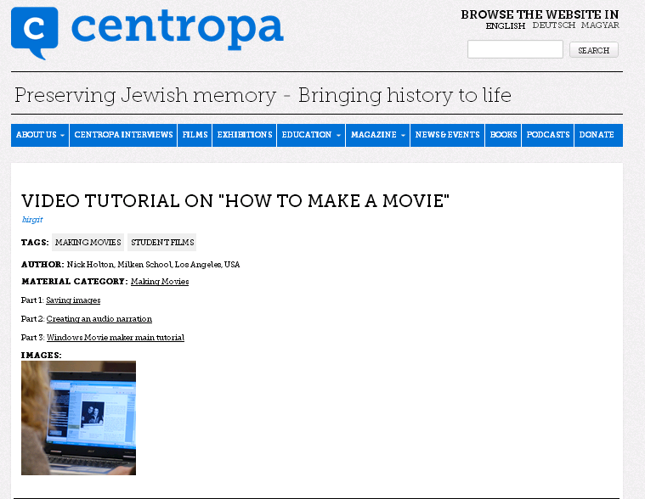

One of the most common digital movie-making programs is Microsoft Windows Movie Maker, and this is, in most cases, sufficient for most students. It's included in older versions of Microsoft Windows.
In more recent versions of Windows, Microsoft has not included Movie Maker, but there are programs available on the Internet that perform the same tasks and carry out similar functions.
If it is not already installed on your computer, as of this writing, you can download it for free at the URL below as part of Windows Essentials Suite.
http://windows.microsoft.com/en-us/windows-live/essentials
A screen capture of the interface you first see if you open Movie Maker, appears below.

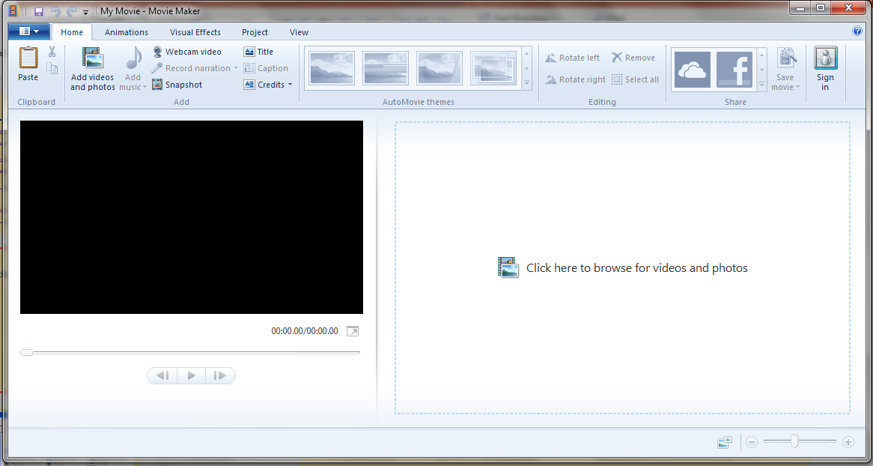

There are other digital movie-making programs available on the Internet; you only need to conduct a search. Two others are Sony Vegas and Apple iMovie.
Some digital movie-making programs are also available on the Internet for a free 30-day trial.
The Internet has many resources that allow you to choose, download, and include sounds to enhance dramatic moments or events in your film, such as a door slamming shut, a gate closing, a locomotive chugging, a whistle blowing, a steamship horn, troops firing weapons, etc.

Screen Captures (aka Screen Shots)
A screen capture program allows you to capture and crop images and save them in .jpg format for later use. You can also pause films and use the screen capture program if you come across a shot in a film that you would like to use.
Microsoft Windows includes a free screen capture program called "Snipping Tool"; it is very easy to use and, most of the time, you only need to use the most basic functions it has to offer.
If you would like a somewhat more sophisticated screen capture program, you can probably download one from the Internet; some of them, however, are not entirely cost-free.
One program is called FastStone Capture and it’s downloadable from the Internet.
People who know how to work with PhotoShop may also want to use the program to cut and crop pictures.
Remember that it is important to take high quality photos and make high resolution scans that will look good when they are moved into your film.
Important reminder: Give these captured images names when you save and catalogue them in your files; they will be much easier to locate later when making the film.

Some more tips (thanks to Centropa)
- Make sure your software allows you to “Import” the materials you have collected.
- Import all materials so that you can arrange them into an organized film.
- Your software will have a “timeline” or a “project area” where you can arrange your materials to create your film.
- Consider performing your narration first at the speed and tone you wish and then add the materials.
- Once your narration is complete, add your images, audio files, music, video clips (if any), and sound effects.
- Proofread and Spellcheck ALL OF YOUR WRITING.
- Remember to save FREQUENTLY during the movie making process!

Additional Info about Genealogy
As mentioned earlier, MyHeritage.com and Beit Hatfutsot - the Museum of the Jewish People - have put together a project to preserve Jewish family trees. For three decades, Beit Hatfutsoth has been collecting digital information on many topics, all aimed at preserving the history of the Jewish people, including family trees with millions of records. Its multimedia database includes genealogy, surnames, communities, photographs, film/video, and music.
Check out the website http://tracingthetribe.blogspot.com/2009/12/saving-trees-myheritage-beth-hatfutsot.html - Tracing the Tribe: The Jewish Genealogy Blog
Have a genealogy question? Send it to ask@tracingthetribe.com
There are also many other genealogy websites on the Internet and all of them help you create family trees.

Final Steps (thanks to Centropa)
Film Credits
Your film must have closing credits, just as all films do.
At the end of the film, give yourself credit and list all the names of people who helped in the production of the film, who helped in the research, in interviews, in gathering documents, etc. Thank anyone and any organization that also helped. Give credit where credit is due. Be generous.
Be sure to list the places and organizations from where you got your information – websites, museums, organizations, educational institutions, map sites, etc.
Provide URLs for websites.
You may also wish to dedicate the film to someone or to some people.
If your credits "roll", be sure to do it slowly enough for the viewers to read the text.
If your screen credits fade in and out, again, be sure you do it slowly enough for the viewers to read them.
Look at the end credits of Centropa films to see how you can model your own credits.
Save your film as a .MOV or an MP4 file.
Save the finalized version to your computer. You can copy it to a DVD-R, a disk-on-key, or you can load the film onto YouTube making it instantly available to your family, your classmates, and to the world.

